WEEK 2 INTERNSHIP REPORT | MEDICAL DEVICE PROTOTYPE MODELLING USING CAD
Virtual Prototype of the Smart Diabetic Foot Monitoring Insole
Nishadevi M | Biomedical Engineering, Sri Ramakrishna Engineering College | YuvaIntern – Online Internship

1. PURPOSE AND SCOPE
This report documents the virtual prototype of the insole concept specified in Week 1 (pressure and temperature sensing, low-power BLE electronics, removable pod). The Week 1 design was reviewed, reduced to its essential components, and converted into a dimensioned 3D assembly of 11 modelled parts. Basic operational checks were then run on the model: pod removal kinematics, a structural check of the electronics-pod lid, clearance and interference checks, and mass properties. The model is a design-feasibility prototype; it is not a manufacturing drawing set and no physical testing has been done.

2. MODELLING APPROACH
Tool and method. The assembly was built as a parametric 3D model using a custom Python/NumPy modelling script (all dimensions are variables in a single parameter block); no commercial CAD package was used. Units are millimetres; the model is a right insole with +X lateral, +Y toward the toes and +Z up. Each part is exported as a binary STL mesh, with a merged assembly file. Screenshots in this report are rendered directly from those files. Because STL is a faceted mesh, it is suitable for viewing, 3D printing and import into CAD tools, but it is not a parametric solid (STEP/IGES export would need a B-rep CAD kernel).
Refinements to the Week 1 concept. (i) Sensor set fixed at five FSR pressure sensors (P1–P5) and three NTC thermistors (T1–T3) with eight FPC traces routed to one pod edge; (ii) the electronics pod is 42 × 24 mm and sits in a pocket at the medial arch, away from the load-bearing zones; (iii) pod access through a hinged flap in a low arch dome, so the pod can be removed without disassembling the insole; (iv) main stack thickness 4.25 mm, inside the Week 1 target of under 5 mm; (v) lid and cavity dimensions revised after the structural check (Section 4.2).
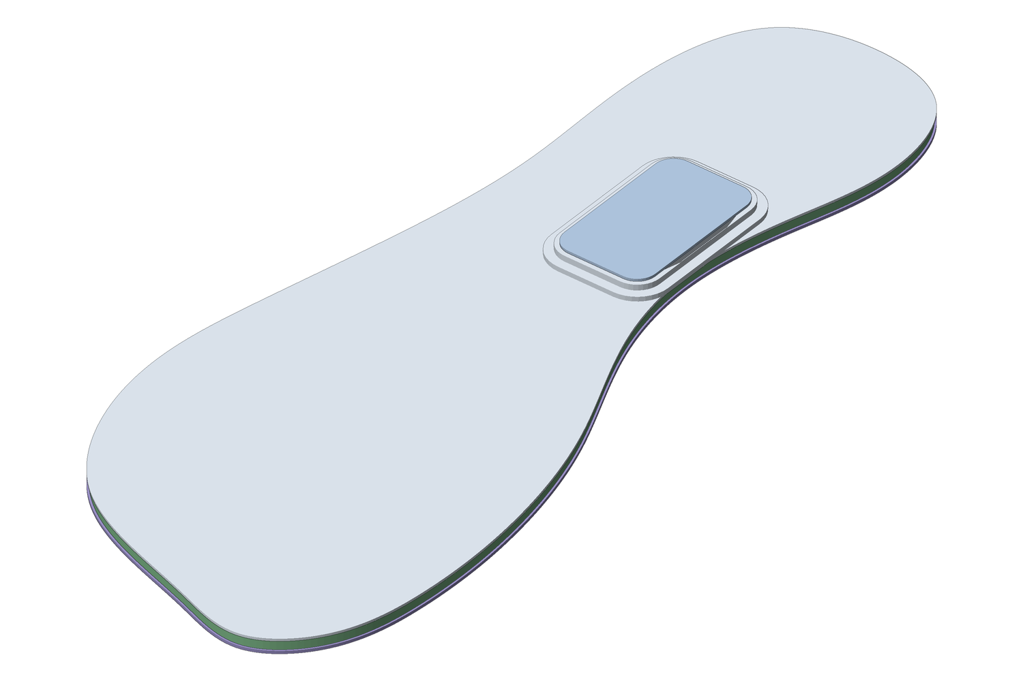
Figure 1. Assembled virtual prototype (right insole, isometric). Overall size 269 × 105 mm; main stack 4.25 mm; arch dome peak 7.9 mm.
Table 1. Part list, materials, key dimensions and function (numbers match Figure 2).
No. | Part / file | Material | Key dimensions (mm) | Function
1 | 01 Base layer | TPU | 0.8 thick; full outline | Structural support; carries pod floor
2 | 02 Cushion layer | EVA foam | 2.6 thick; pod pocket 42.6 × 24.6; FSR pockets Ø13.0 × 0.45; NTC pockets Ø4.5 × 0.6 | Shock absorption; seats sensors flush
3 | 03a FSR sensors (×5) | Thin-film FSR | Ø12.0 × 0.45 | Plantar pressure at heel, midfoot, 1st/5th metatarsal heads, hallux
4 | 03b NTC sensors (×3) | NTC thermistor | Ø3.0 × 0.6 | Local temperature at heel, 1st metatarsal region, hallux
5 | 03c FPC traces | Polyimide / Cu | 1.0 wide × 0.15 thick | Routes 8 channels to the pod
6 | 04 Top cover | PU-coated textile | 0.7 thick + 2-tier arch dome | Skin contact; moisture management
7 | 05 Access flap | PU film | 44.4 × 26.4 × 0.7 | Hinged cover for pod removal
8 | 06 Pod housing | PA12 (SLS/MJF) | 42 × 24; floor 0.8; wall 1.0; cavity 3.6 deep | Protects electronics; sweat barrier
9 | 07 Pod lid | PA12 | 42 × 24 × 2.0 | Carries foot load over the pod; seals
10 | 08 Li-Po cell | Li-polymer | 25 × 20 × 3.0 (assumed ~150 mAh class) | Power source
11 | 09 PCB + MCU module | FR-4 + BLE SoC | 19 × 13 × 1.0 + 12 × 10 × 1.5 | Sampling, processing, BLE link

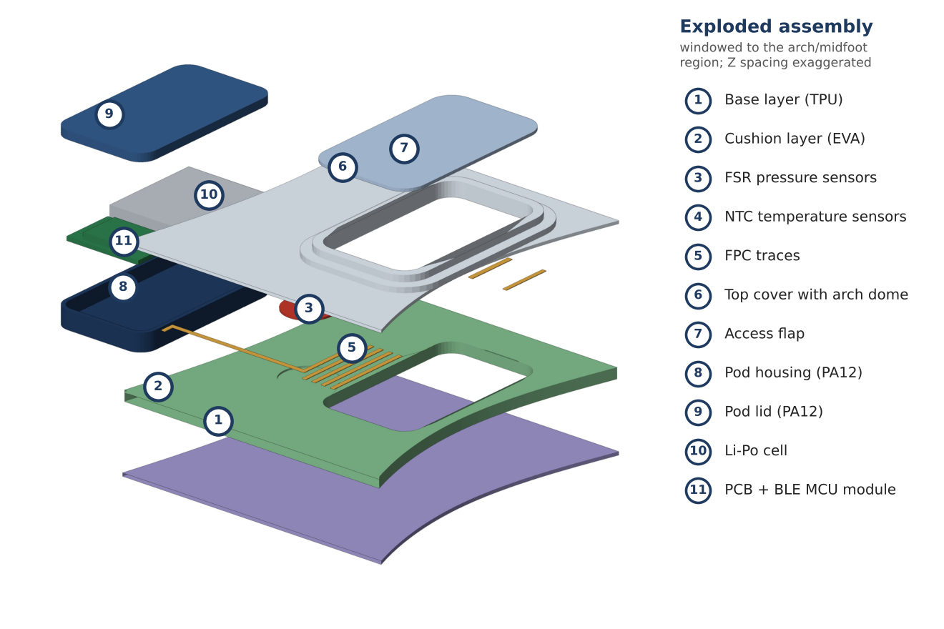
Figure 2. Exploded assembly with numbered parts (windowed to the arch and midfoot region for clarity; Z spacing exaggerated).
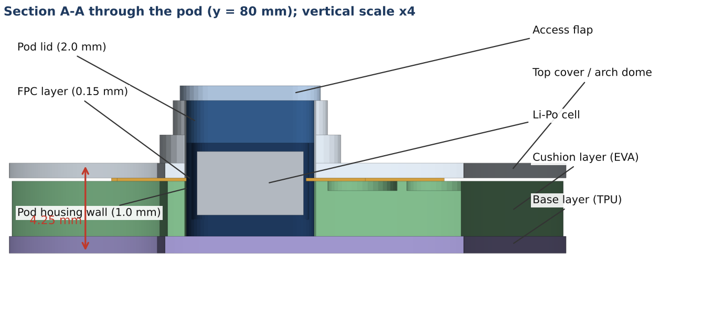
Figure 3. Section A-A through the electronics pod showing stack-up and pod seating (vertical scale ×4).

3. KEY DESIGN CHOICES
- Thin layered stack: base 0.8 + cushion 2.6 + FPC 0.15 + cover 0.7 = 4.25 mm. FSRs and thermistors sit in blind pockets in the foam, so the top surface stays flat and the sensor face is not a pressure point.
- Pod at the medial arch: the arch carries little load in normal gait, so the thickest component is placed there. The 0.3 mm per-side pocket clearance allows hand insertion while the arch dome holds the pod in place.
- Pod height: cavity depth 3.6 mm holds a 3.0 mm cell with 0.2 mm below and 0.4 mm above; PCB and cell are side by side (not stacked) to keep the dome low (peak 3.65 mm above the main stack).
- Removable, sealed pod: the pod can be detached for charging and cleaning (Week 1 hazards H6 and H10) and leaves a flat, sealed insole behind.
- Non-crossing FPC routing: forefoot traces run in separate lanes along the foot axis, heel traces enter from below and P2 enters from the side, so no trace crosses another (Figure 6, Appendix).
- Materials: PA12 for the rigid pod (strength, sweat resistance, SLS/MJF printable); EVA and TPU for comfort and flexibility; polyimide FPC for repeated bending.

4. SIMULATION AND VERIFICATION RESULTS

4.1 Pod removal kinematics and clearance
Removal was simulated by transforming the CAD parts: the flap rotates 75° about its lateral hinge, then the pod translates vertically (Figure 4). The flap stays above the dome at all angles (0.0 mm minimum height above the hinge line) and the pod leaves its pocket on a straight path with 0.3 mm clearance per side, so no part interferes during removal.
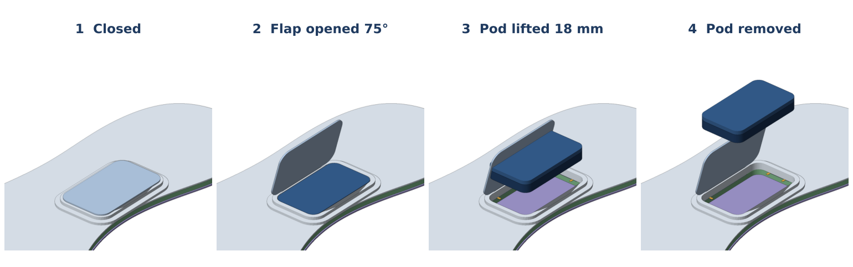
Figure 4. Pod removal sequence: closed, flap opened 75°, pod lifted, pod removed.

4.2 Structural check of the pod lid
The lid was modelled as a simply supported rectangular plate (40 × 22 mm span) under uniform pressure (Navier double series) with assumed PA12 properties (E = 1700 MPa, ν = 0.4, yield 48 MPa). Design pressure is 200 kPa (conservative for the low-load arch); 500 kPa is an abnormal case. This is plate theory, not a 3D FEA, and it ignores load sharing through the foam, so results are indicative.
Table 2. Lid design iterations at 200 kPa (v3 is the final design).
Version | Lid (mm) | Cavity (mm) | Max deflection (mm) | Clearance to cell (mm) | von Mises (MPa) | Safety factor | Verdict
v1 | 1.0 | 3.4 | 2.61 | 0.2 | 49.3 | 0.97 | Fails (SF < 1)
v2 | 1.5 | 3.4 | 0.77 | 0.2 | 21.9 | 2.19 | Stress OK; lid touches cell
v3 (final) | 2.0 | 3.6 | 0.33 | 0.4 | 12.3 | 3.89 | Pass

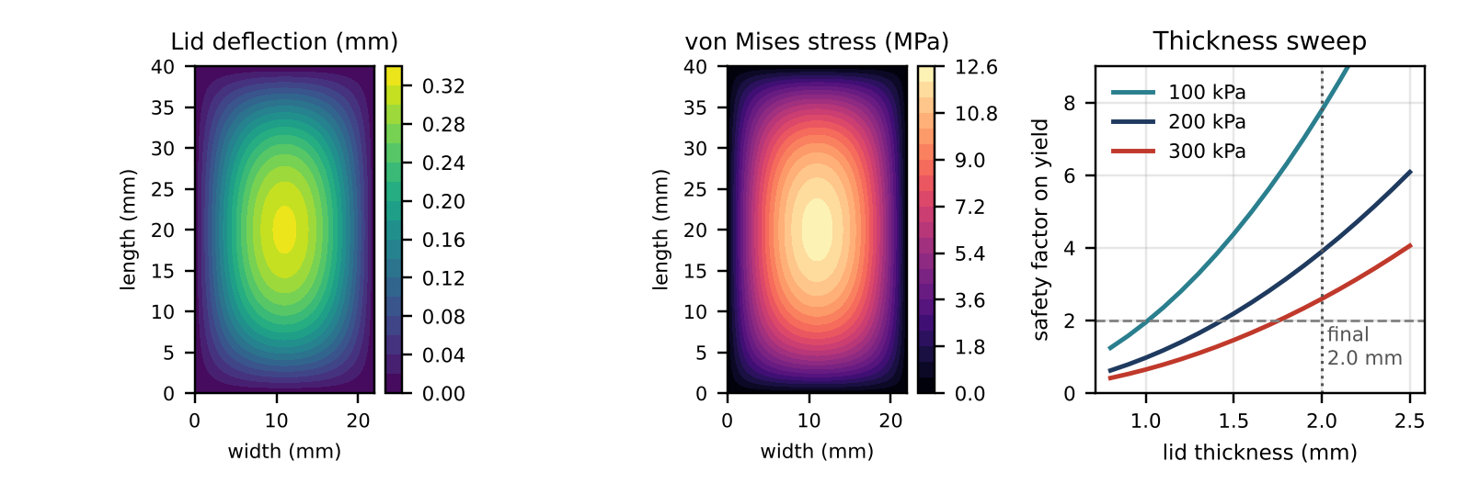
Figure 5. Final lid (2.0 mm): deflection and von Mises stress at 200 kPa, and safety factor versus lid thickness.
Result: the 1.0 mm lid would yield; 1.5 mm fixed the stress but deflected 0.77 mm, beyond the 0.2 mm clearance. The final 2.0 mm lid with a 3.6 mm cavity gives a safety factor of 3.9 and 0.33 mm deflection (0.4 mm clearance). At 500 kPa the safety factor is 1.56, but the 0.82 mm deflection would touch the cell, so a central rib is recommended.

4.3 Other model checks
Table 3. Additional checks derived from the model.
Check | Method | Result
Assembly clearances (mm) | Bounding-box check of pod internals | Cell–wall 1.0 (X) / 0.4 (Y); PCB–wall 1.5 (X) / 0.4 (Y); cell–PCB 1.2; no interferences found
Foam compression | ε = p / E, assumed E = 1.0 MPa | 0.52 mm (20%) at 200 kPa; 1.04 mm (40%) at 400 kPa; foam is nonlinear, so to be tested
FPC bending strain | ε = t / 2R, t = 0.15 mm | 0.25% at R = 30 mm; R must stay ≥ 25 mm for a 0.3% strain limit (check supplier limit)
Mass properties | Mesh volumes × assumed densities | Total 51.5 g: pod 8.1 g, insole layers 43.4 g (cell and PCB masses assumed)

5. CONCLUSIONS AND NEXT STEPS
The Week 1 concept fits a 4.25 mm insole stack with a removable 6.4 mm pod at the medial arch, and the checks produced a real design change (lid 1.0 → 2.0 mm, cavity 3.4 → 3.6 mm). Limitations: STL mesh without parametric history, assumed material properties, plate-theory check, no physical validation. Next steps: rebuild in a B-rep CAD tool (STEP export, drawings), run 3D FEA with a foot-pressure map, add a lid rib, 3D-print the pod and bench-test it.

APPENDIX – PLAN LAYOUT AND CAD FILE PACKAGE
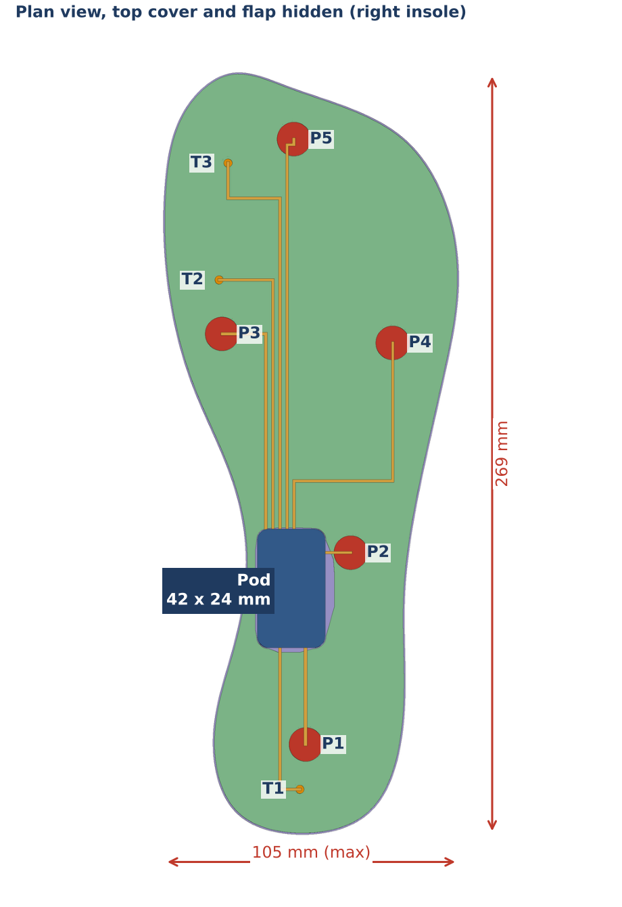
Figure 6. Plan view with top cover and flap hidden: sensor positions (P = pressure, T = temperature), FPC routing and pod location.
Table 4. Sensor and feature coordinates (mm, in model coordinates; Figure 6 axes).
Item | X | Y | Item | X | Y
P1 heel | 56.2 | 31.8 | T1 heel | 54.1 | 15.9
P2 midfoot (lat.) | 72.1 | 99.6 | T2 1st MT region | 25.4 | 196.1
P3 1st MT head | 26.5 | 177.0 | T3 hallux | 28.6 | 237.4
P4 5th MT head | 86.9 | 173.8 | Pod centre | 51.0 | 87.0
P5 hallux (opt.) | 51.9 | 245.9 | Pod size | 24 × 42 | h 6.4

Table 5. Delivered files (folder CAD_Package/).
Folder / file | Content
STL/01 … 09_*.stl | One binary STL per part (11 files), mm units, common origin
STL/00_full_assembly.stl | All parts merged in assembled position
renders/*.png | Screenshots used in this report (assembly, exploded, section, removal, plan, simulation)
source/geometry.py, simulation.py | Parametric model (all dimensions in one block) and calculations; re-run to regenerate every file
README.txt | Coordinate system, part list, how to open the files in any CAD or mesh viewer

APPENDIX (continued) – CAD MODEL SCREENSHOTS
Additional views rendered directly from the exported STL files of the virtual prototype: external views of the complete assembly, the sensor layer and FPC routing with the cover removed, and the internal layout of the electronics pod.
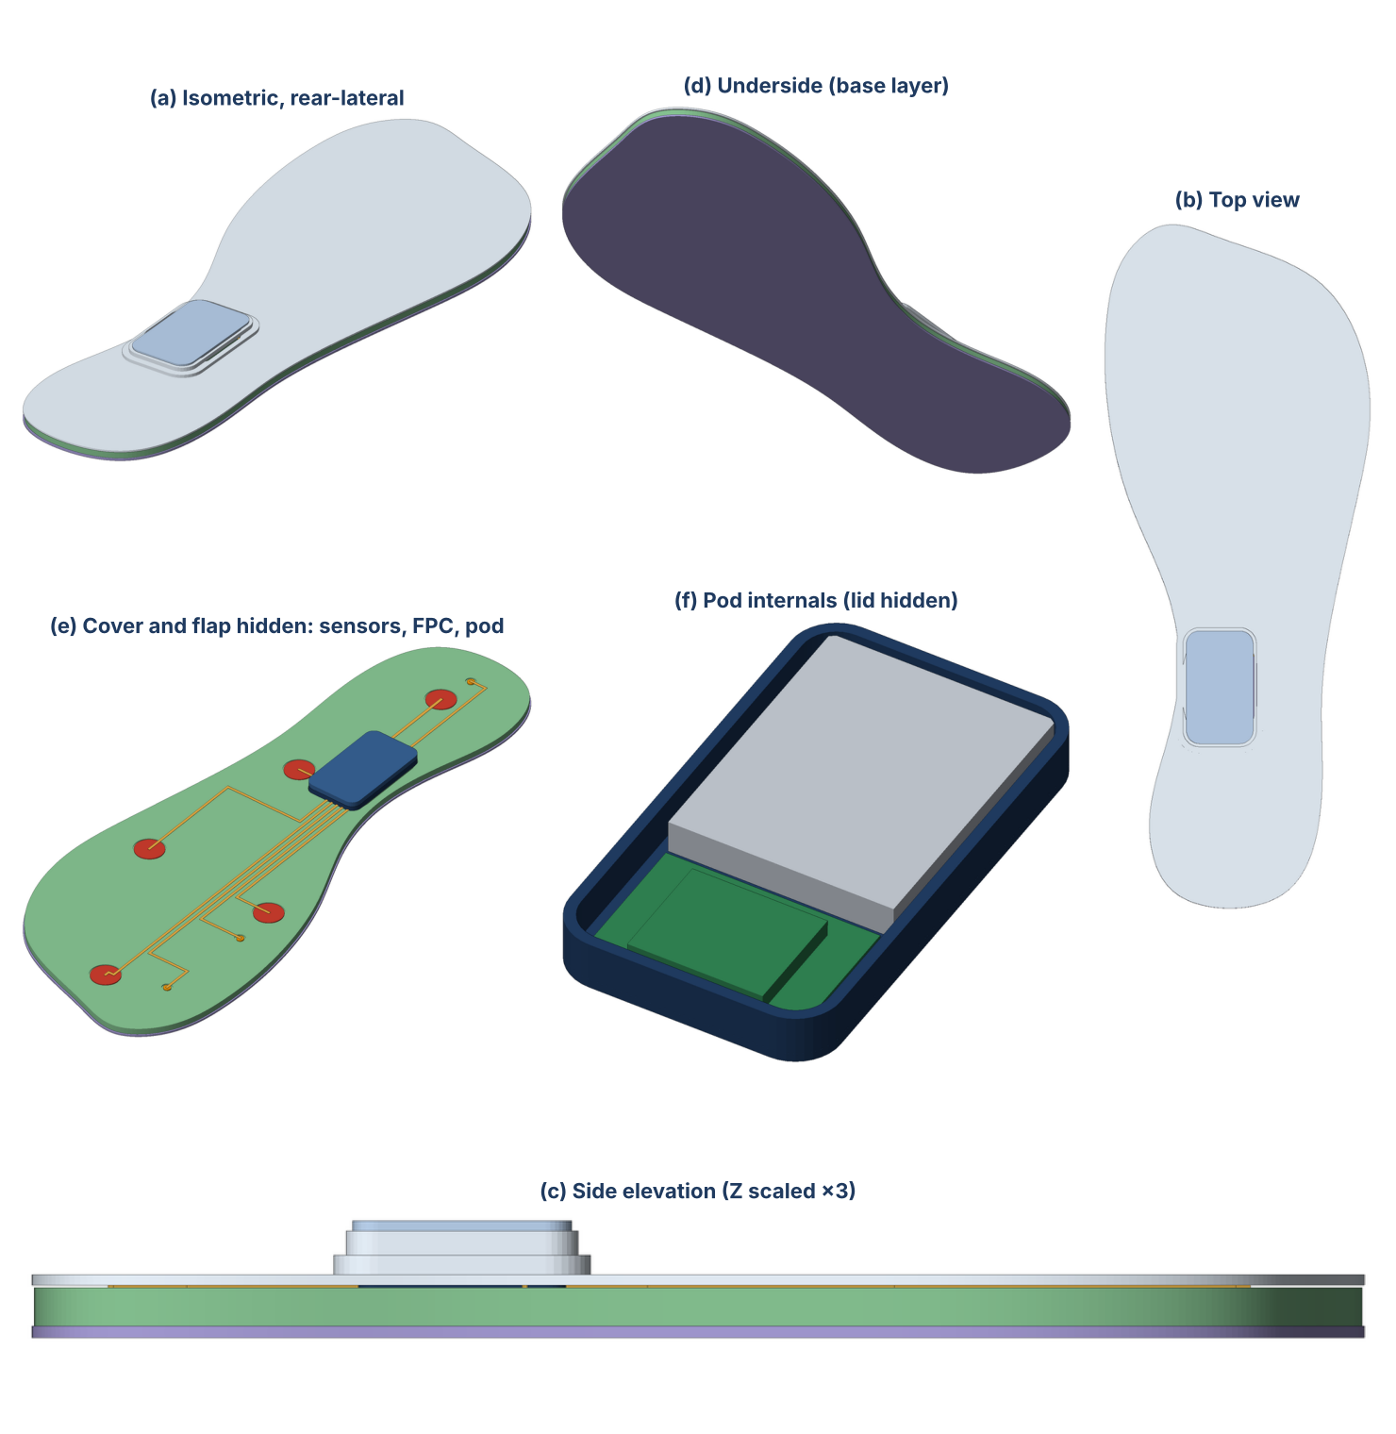
Figure 7. Additional CAD screenshots of the virtual prototype: (a) rear-lateral isometric, (b) top view, (c) side elevation, (d) underside, (e) cover and flap hidden showing sensors, FPC traces and pod, (f) pod internals with lid hidden.

